**SMART FUEL METER**

MADAWALA LIYANAGE CHATHURA LAKMAL PERERA

A dissertation submitted in partial fulfilment of the requirements for the Bachelor of Science

External Degree in Electronic and Automation Technology

Of the

University of Colombo, Sri Lanka

DECEMBER 2021

Table of Contents

1. ABSTRACT 1

2. INTRODUCTION 2

2.1 OBJECTIVES 3

2.2 Scope 3

3. LITERATURE REVIEW 4

4. MATERIALS & METHODS 5

4.1 Hardware 5

4.1.1 Temperature Sensor 5

4.1.2 AJ-SRO4M Ultrasonic Sensor 6

4.1.3 NodeMCU ESP8266 Microcontroller 8

4.2 SOFTWARE 9

4.2.1 Arduino IDE 9

5. RESULTS & EVALUATION 10

5.1 Ultrasonic Sensor Testing 10

5.2 DS18b20 Temperature Sensor Testing 11

5.3 Working principle of IoT Project 12

5.4 IMPLEMENTATION 13

6. DISCUSSION 14

6.1 Communication Protocols 14

6.1.1 Temperature Sensor Communication Protocol One Wire 15

6.1.2 ESP 8266 Data to HTML Page 15

6.1.3 USART Serial Communication 15

6.2 Outcoming of Problem Solution 16

7. CONCLUSION 18

8. REFERENCES 18

9. APPENDIX 19

9.1 Data Sheet of Sensors 19

9.1.1 DS18b20 Temperature Sensor 19

9.1.2 AJ SR04M Ultrasonic Sensor 19

9.1.3 Schneider xxs18b1am12 product data sheet 19

9.2 Schematics Design 19

9.3 CAD Design 20

9.3.1 Detailed Design 20

9.3.2 Dimension Design 21

**LIST OF FIGURES**

Figure 1 : UST Monitoring System 2

Figure 2 : Long probe type DS18B20 temperature sensor 6

Figure 3 : Ultrasonic Sensor with Module 6

Figure 4 : Replacement of R19 changing mode of Module 7

Figure 5 : Module Output Format Description 7

Figure 6 : Module Startup Flow Chart 8

Figure 7 : NodeMCU ESP8266 Pinout 9

Figure 8 : Arduino IDE 10

Figure 9 : Ultrasonic Sensor Reading 11

Figure 10 : Temperature Sensor Reading 12

Figure 11 : Block Diagram of Working Principle 13

Figure 12 : UART Communication Data 16

Figure 13 : Schematic Design 19

Figure 14 : Detail Design 20

Figure 15 : Dimensions Design 21

**LIST OF TABLES**

Table 1 : Project Work Distribution 13

Table 2 : Communication protocol for selected components 14

Table 3 : Voltages at which 1-Wire communication is performed 15

Table 4 : Problem & Solution 17

# ABSTRACT

We use fuel in our automobiles, equipment, and industries on a regular basis, thus it is a need in our lives. Petrol is a combustible liquid with a low boiling point (750 C) that poses a significant health risk to humans. The source of gasoline distribution is the fuel pump. We needed control techniques to keep track of the liquid level in the fuel pump tank and its temperature. Employees at gas stations are responsible for checking the level of gasoline and monitoring its temperature by entering the tank. This has an impact on their health due to the fuel fumes they breath, as well as a risk to their lives if petrol tanks are exposed to fire. Human life is more valuable and significant than everything else. Because we live in the twenty-first century, we can use smart electronics to monitor the environment and get better results without involving humans. This project is being carried out to monitor the temperature and petrol level in real time using a petrol pump. The employees of fuel pumps who check the petrol level and temperature face health and life risks.

In this work has provided the smart solution to monitor the fuel level through ultrasonic sensor (AJ-SR04M) and temperature sensor (DS18b20) interfaced with NodeMCU. Notifications are sent to a HTML page to monitor the fuel volume and temperature continuously. ESP8266 NodeMCU WIFI Microcontroller is programmed through Arduino IDE. Data to the webpage is sent through the Local Area Network (LAN) with Wi-Fi connection.

# INTRODUCTION

The world is focused on technology development in the twenty-first century since it is the most valuable and enabling commodity. The ability of modern electronic technologies to enable high speed, low cost, and dependable functioning of the components combined into a system on chip is one of its most important features. As a result, the globe is shifting toward smart solutions since they minimize material use, which lowers costs and expands market opportunities. To operate its systems, the world needs a smart answer for their machines. By incorporating controls through microcontrollers, the electrical field has supplied us with a tremendous deal of control over the machine. These components allow us to create commands to operate the machine.

The workers at the gas station oversee measuring the ambient temperature of the tanks. As a result, it is critical to have a plan in place to avoid having people work in gasoline tanks. This technique has been proposed to ensure the safety of employees at gas stations. Because of the high rates of goods, society is severely weak in human safety procedures. In this project, a real-time solution was suggested.

As a result of pollution caused by unintended subsurface leaks, recent attention has been drawn to the complex subterranean system's and surrounding environment's safety hazards. The damage restoration procedure and defect identification practice have received a lot of attention. According to research on related defenses, there are now technical complications that raise questions about the efficacy of remedial efforts and the robustness of condition monitoring systems at gas stations.

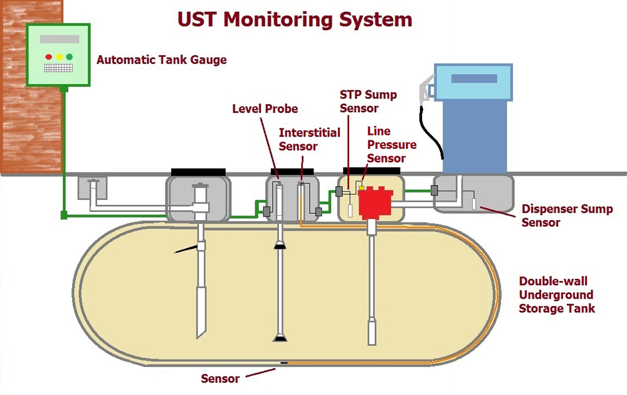

Figure 1 : UST Monitoring System

Underground storage tanks (USTs) have long been used at gasoline stations to store significant amounts of fuel. Throughout their service lives, the complicated containers, which are typically located beneath petrol stations, laundry enterprises, and nearby houses, are unavoidably exposed to pollutants, oxidation, and erosion. Deteriorating symptoms usually focus on high-risk areas such metal buildings, tank bases, sewage pipelines, pumps, and safety valves. The degradation is caused by harsh working circumstances, metal and liquid interactions, specific element gravity changes between fluid and tank surfaces, fatigue, mismanagement, and faulty assembly. In addition, the subsurface component of UST functioning is a double-edged sword: it reduces surface area needs while increasing monitoring complexity.

This research presents the building of a model of a gasoline station reservoir surveillance system utilizing the Internet of Things (IoT). In Sri Lanka, the current technique for detecting the amount of gasoline in an underground tank is to use a dipstick, which is inefficient and unsafe. The recommended monitoring system is completely automated and offers a real-time readout of the fuel level and temperature in the underground storage tank utilizing an ultrasonic sensor and a waterproof temperature sensor.

# OBJECTIVES

The project's goal is to measure the gasoline station using various methods and to tell the concerned person using various sources. The goal of this project is to design a hardware circuit for a gasoline measuring system utilizing a microcontroller. Safety is important to everyone, whether it is intended to guard against a little or major threat. The proposed gasoline storage tank monitoring system will include two-tab user interfaces. There are two tabs for gasoline volume and fuel temperature. The gasoline capacity in the subterranean storage tank will be displayed on the first tab (in demonstration volume is in cm3) and other with temperature of the tank. The fuel volume is displaying real-time with volume and remaining percentage. Other tab is displaying whether the temperature is within the relevant range or whether the range indicates a higher or lower temperature value.

# Scope

The system begins with the initialization of the microcontroller (on the NodeMCU board). The fuel and temperature levels will then be measured concurrently by both sensors. The fuel volume will be calculated, and the temperature of the fuel will be processed by the microcontroller. HTML page will alert the user remaining fuel volume of tank and display the temperature of the tank whether it’s in relevant range or not.

# LITERATURE REVIEW

A few important traditional checking techniques have been developed to address a wide range of applications for various situations. For basic inspection, a visual check by skilled laborers, for example, is appropriate. For ferrous and non-ferrous parts, an oil and garbage inspection is necessary to find any chips, holes, or locations where the covering may have isolated. Using the major heat move concept, the thermography technology detects underlying temperature changes related to material characteristics and conductivity. SCADA (Supervisory Control and Data Acquisition) is an online boundary-following organization that spends a substantial amount of time studying tribological phenomena with a wide range of participants.

When combined with suitable data storage, SCADA's focused control framework may provide a long-term review of a few pieces of equipment or large offices. The vibration-based examination is another excellent option because of its extremely speedy segment finger impression design identification and finding. Despite the previous approaches' shown success, they are poorly adapted to apply to UST due to the restricted and difficult-to-reach qualities of the subsurface environment. Furthermore, the poor connection between the time-shifting segments, as well as the equally long filling-release cycle lengths, contribute to the lengthy computation and delayed reaction. USTs are often unaffected by movement type checking due to the static concept of the segments and the multiple strong qualities of the result, such as the fluid volumetric stream rate. Due to the sluggishness of subsurface structures, a comprehensive inquiry into condition-checking methods has been undertaken in order to reduce ecological conflict and uncover a few visible symptoms.

# MATERIALS & METHODS

Experiments are done out using various ways and characterized to determine whether or not it will operate well. As we work on this project, we experiment with various working methods in order to find the best answer. Different ways might be used to address the same problem; the components listed below were chosen after extensive investigation and analysis of similar works. The effort is divided into two parts: hardware research and software research. The approach that will be utilized for this project is listed below.

# Hardware

The components that go into making the circuit and dealing with physical atmospheric readings. The transducer is a module that translates data from the environment and transfers it in electrical form from sound, wave, temperature, and other sources. The transducer is sometimes referred to as a sensor since it perceives the surroundings. The microcontroller, on the other hand, is the device that interferes with the other components. Programming is done to enable the microcontroller for the specified sensor. In this project, an ESP8266 microcontroller is utilized, which is programmed in Arduino language using the Arduino IDE.

# Temperature Sensor

We're utilizing a DS18B20 temperature sensor, which is a 1-Wire bus communication sensor, which implies that several sensors may be connected to the same bus and data collected separately. It measures temperatures from -55°C to 125°C in 9-bit to 12-bit Celsius, with precision ranging from -10°C to 85°C with a tolerance of +/-0.5°C. The data is taken from DQ, as this pin is utilized with the microcontroller. This sensor has three wires: ground, VCC, and DQ. Temperature sensors come in a variety of forms and sizes; the sensor in use has lengthy probes that allow it to monitor temperature over a greater distance. The long probe type DS18B20 temperature sensor is shown in the diagram. It communicates using the 1-Wire bus, which implies that to interface with a microcontroller, it is best to record line (and ground) with a 4.7k Ohm pull-up resistor. In damp situations, the Waterproof Temperature Sensor DS18B20 is a sealed temperature sensor that allows users to precisely degree temperature. In damp situations, the Waterproof Temperature Sensor DS18B20 is a sealed temperature sensor that allows users to precisely degree temperature.

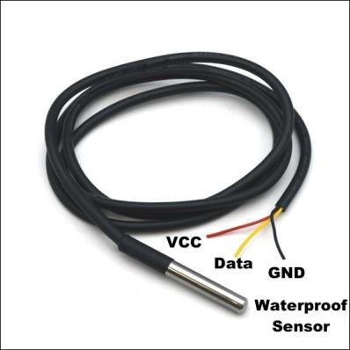

Figure 2 : Long probe type DS18B20 temperature sensor

# AJ-SRO4M Ultrasonic Sensor



Figure 3 : Ultrasonic Sensor with Module

The ultrasonic range module has five functioning modes after attaching it to a 3-5.5V power supply:

**Mode 1:** Common Pulse Width Square Wave (Minimum Power Consumption 2.5mA)

**Mode 2:** Low Power Pulse Width Square Wave (Minimum Power Consumption 40uA)

**Mode 3:** Automatic Serial Port (Minimum Power Consumption 2.5mA)

**Mode 4:** Serial Port Trigger (Minimum Power Consumption 20uA)

**Mode 5:** ASCII Code output (Minimum Power Consumption 20uA)

**Description of the Module Output Format:**

The procedure for changing modes. The mode can be changed in the event of a power outage by adjusting the resistance value of R19 above the module.

Figure 4 : Replacement of R19 changing mode of Module

Figure 5 : Module Output Format Description

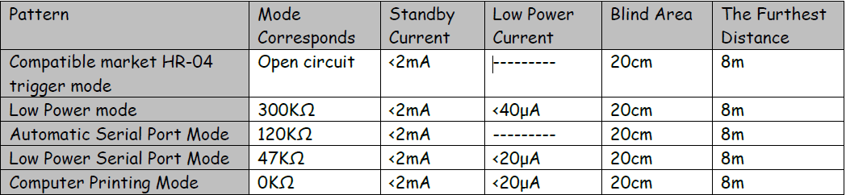

# NodeMCU ESP8266 Microcontroller

Figure 6 : Module Startup Flow Chart

It’s a CH340 chip board designed by LoLin, with unique features like as Wi-Fi connectivity, I/O ports, and ADC inputs. It also has all of the features of a microcontroller. It is simple to use since it can be programmed using the Arduino IDE. It has an operating frequency of 80MHz. It also includes an 80KiB flash memory. We will only evaluate the function of its inputs and outputs in this example since we desire a specific result based on a certain input. The Arduino software is used for all programming and control. The ESP8266 Wi-Fi microprocessor powers the NodeMCU, a low-cost open-source development board. 16 General Purpose Input / Output (GPIO) pins, a Pulse Width Modulator (PWM), a serial 2-wire bus interface (Inter-Integrated Circuit, IIC), a 1-wire interface, and an Analog to Digital Converter are all included on this board (ADC). It has 4MB of flash memory, a system frequency of 80MHz, about 50k of useable RAM, and an on-chip Wi-Fi transceiver.

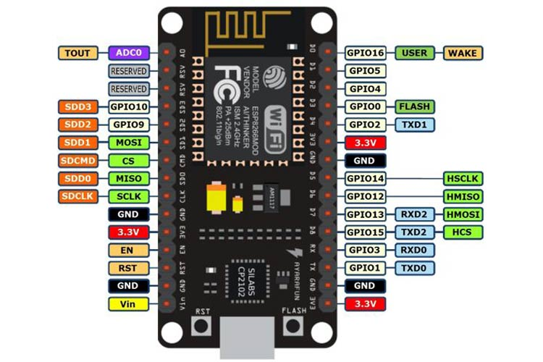

Figure 7 : NodeMCU ESP8266 Pinout

# SOFTWARE

When software programming is included, logics are utilized in the codes, which necessitated brain storming and suggested a well-managed approach to minimize unnecessary lines for code optimization. Programming is an area of self-decision that is applied to a computer to allow it to make decisions on its own. Assume that the system has several situations that it must go through in order to carry out its numerous judgments. Code that has a direct impact on the system's control, movement, working, and speed. Although the controller was a NodeMCU, it was programmed using a C compiler. Many times, logics were implemented in diverse ways in order to improve the system's outcomes. As a result, it has made a significant difference in my ability to use software and interface with devices.

# Arduino IDE

The Integrated Development Environment (IDE) is application development software that combines developer tools into a single user interface. The Arduino IDE is the software that is used to program the Arduino. It has software compilation, uploading, and serial interface capabilities. For debugging reasons, a serial monitor interface that tracks UART communication is offered. The Arduino IDE is a coding environment for Arduino and other microcontroller devices. By hitting the 'Upload' button, the boards are linked to the PC via USB port, and the application is uploaded and built.



Figure 8 : Arduino IDE

# RESULTS & EVALUATION

# 5.1 Ultrasonic Sensor Testing

The AJ SR04M sensor is connected to pins D2 and D1, which are labeled as Echo input and Trig output, respectively. A pulse is transmitted to the 10 by raising it for a brief period of time and then lowering it to zero. At pin 10, a wave is emitted, which is absorbed by the receiver. The distance is calculated by measuring the time spent transmitting and receiving data. Ultrasonic sensors determine distance by emitting and receiving echo waves, similar to how dolphin fishes employ Doppler effects. These fish utilized this trait to calculate the distance between them and their neighbors. Humans have traditionally studied nature in order to enhance their lives. Natural events are employed to determine distance in ultrasonic sensors.



Figure 9 : Ultrasonic Sensor Reading

# 5.2 DS18b20 Temperature Sensor Testing

The NodeMCU's D3 is linked to the data pin of temperature sensor DS18B20. This is a three-terminal module with one pin linked to VCC and the ability to connect it to both 5V and 3.3V. While in the code, we'll do calculations based on the applied voltage. The sensor's other pin is linked to ground. The temperature sensor's operating concept is that as the temperature rises, the resistance of the temperature sensor material rises, and as the resistance rises, the voltage drop across the sensor rises as well. By using an external resistor, we can create a voltage divider that allows us to compare the values. The Dallas temperature library, which works on the basis of one-wire communication, is used by the temperature sensor. The communication protocol section discusses one-wire communication. The data from this sensor may be measured in both degrees and Celsius.



Figure 10 : Temperature Sensor Reading

# 5.3 Working principle of IoT Project

It connects the NodeMCU to the DS18B20 and the AJ SR04M. After uploading the code, the IP address will appear in the serial monitor of the Arduino IDE. This is the web server's IP address. We may enter the IP address into our mobile or computer's web browser, and the temperature data will begin to appear. It will update automatically when the fuel volume and temperature readings change.

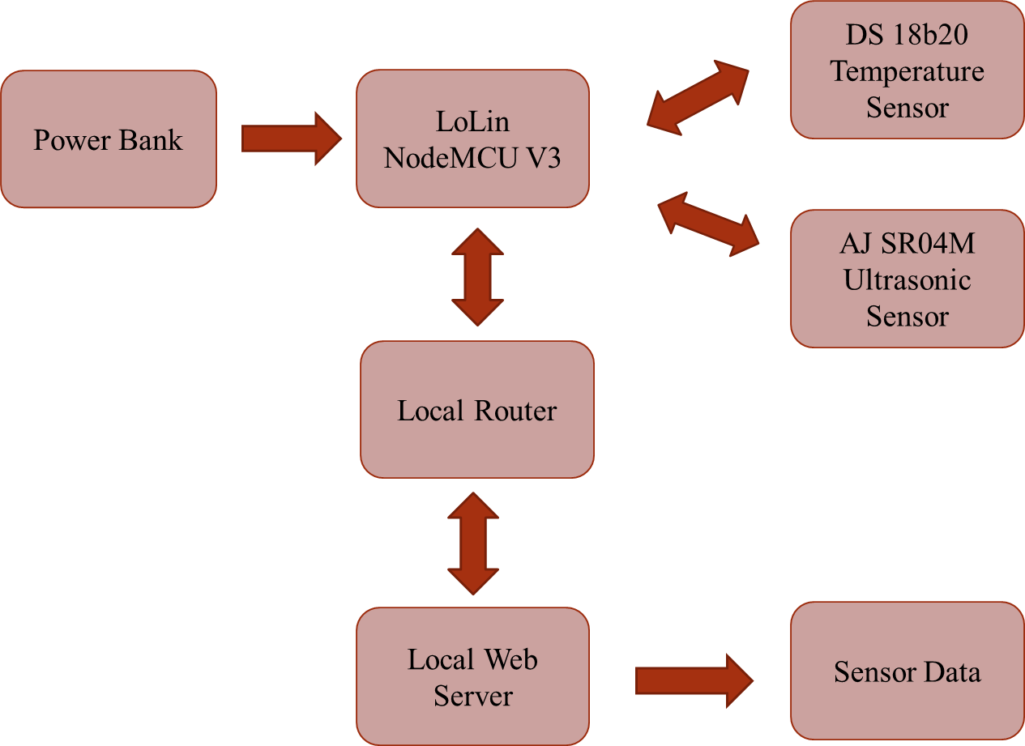

Figure 11 : Block Diagram of Working Principle

# 5.4 IMPLEMENTATION

This project is organized around the characteristics. Each feature is completed thoroughly before moving on to the next. Each feature is then distributed to be coded and tested on hardware. Table 1 has a list that describes the entire work.

Table 1 : Project Work Distribution

|  |  |
| --- | --- |
| Task No. | Task |
| 1 | Components Selection |
| 2 | Algorithm and logics for implementations. |
| 3 | Coding is done for Temperature sensor and Ultrasonic sensor |
| 4 | Implementation is done and tested out in simulation. |
| 5 | Data sending to the HTML page |
| 6 | Merging of the Code and Final testing |
| 7 | Report Writing |

# DISCUSSION

If this project is installed Manager can get real time update about remaining fuel volume of station & able to order immediately if there’s an emergency essential. The suggested monitoring system is fully automated and provides a real-time reading of the fuel level and temperature occurring in the storage tank and no health risk for workers, when someone open to get reading of dipstick, this affects their health because of petrol fumes inhaled by them as well as risk to their life if petrol tanks get introduce to the flame.

This paper aims to examine the approaches for monitoring the state of underground fuel storage tanks (USTs) in a fuel tank station in depth. Underground storage tanks in gas stations have long been a preferred substance reserve method in most petrol stations because to its large capacity and minimum floor area requirements. As a result of pollution caused by unintended subsurface leaks, recent attention has been drawn to the complex subterranean system's and surrounding environment's safety hazards. The damage restoration procedure and defect identification practice have received a lot of attention. According to research on related defenses, there are now technical complications that raise questions about the efficacy of remedial efforts and the robustness of condition monitoring systems at gas stations.

# Communication Protocols

Various modules have been added to this project, each with their own communication mode and unique protocol. The components that need to describe the communication protocol are the HTML page and the temperature sensor and data for the ESP 8266.

Table 2 : Communication protocol for selected components

|  |  |  |
| --- | --- | --- |
| No: | Module / Component | Communication Protocol |
| 1 | Temperature Sensor | One Wire |
| 2 | Data to HTML Page | Wi-Fi |
| 3 | Data to NodeMCU from IDE | USART |

# Temperature Sensor Communication Protocol One Wire

The One Wire communication protocol is a half-duplex bidirectional serial communication using a single data line. 1Wire transmits data with a unique address and data size, so various modules can be added. Each component is unique, so it can work on different devices. Typically, 1-bus devices do not include a power pin and draw power from the 1-wire bus via a parasitic power supply. There are 4 voltages that 1 wire communicates with. The table shows the voltages at which the communication protocol occurs on the data bus. Table 3 shows the voltage at which 1Wire operates.

Table 3 : Voltages at which 1-Wire communication is performed

|  |  |  |
| --- | --- | --- |
| No: | Minimum Voltage | Maximum Voltage |
| 1 | 1.71 | 1.89 |
| 2 | 1.71 | 3.63 |
| 3 | 2.97 | 3.63 |
| 4 | 2.8 | 5.25 |

# ESP 8266 Data to HTML Page

The communications used in the project represent multiple topologies as data travels from the ESP8266 to Wi-Fi and then through other domains to the thing database. Wi-Fi is the generation of Wi-Fi that uses radio waves to provide internet services. Statistics are converted into radio signals that are transmitted through the antenna. We commonly refer to Wi-Fi as Wi-Fi Local Area Network (WLAN). A router is used to send and receive tokens. The resulting statistics are decoded and converted to percentage load statistics using a personal computer.

# USART Serial Communication

In general, USART is known as serial communication in the literature. The Universal Synchronous/Asynchronous Receiver/Transmitter (USART) supports synchronous and asynchronous communication modes. The difference between synchronous and asynchronous is that synchronous requires a clock and data whereas asynchronous requires only data. In synchronous mode, data is transferred one byte at a time, while synchronous data is transferred in blocks. Synchronous mode transfers data at a fixed rate, whereas asynchronous mode does not transfer data at a fixed rate. The communication being performed is USART, which is an asynchronous USART communication function. UART communication does not require a clock. Data from Arduino is sent to ESP8266 via UART/serial communication. ESP and Arduino need to be grounded in common, so there is no need to threshold them. Usually voltage level differences give false readings, so connect ground to bring it to a common level. UART baud rates are specified in bits per second (bps) (e.g. 9600 bps).

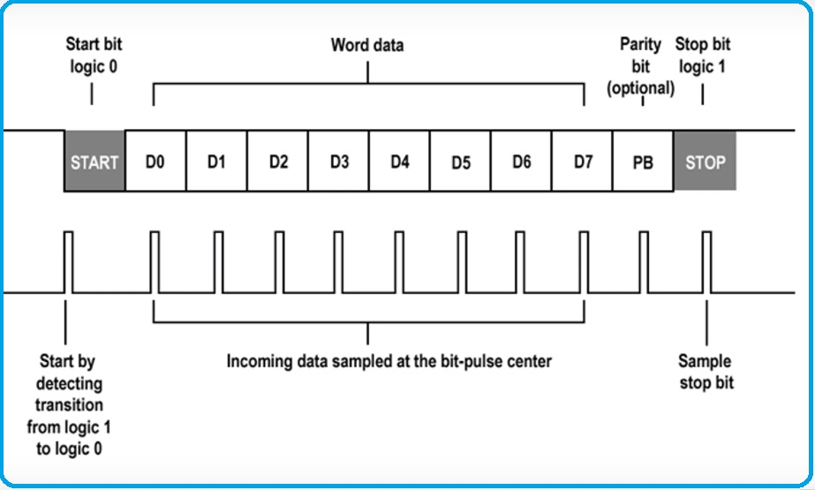

Figure 12 : UART Communication Data

# Outcoming of Problem Solution

In this project there are few problems facing while constructing the demonstration. Calibration of Ultrasonic Sensor, making stable power in ESP 8266 & access in outside of Local Area Network (LAN). Problem solution table is listed below.

Table 4 : Problem & Solution

|  |  |
| --- | --- |
| **Problem** | **Solution** |
| If manager isn’t in LAN area cannot access the webpage | Buy a domain & host in a server   * Create data file including HTML & CSS * Installing ESPAsyncWebServer library & Async TCP Library for ESP8266 |
| AJ – SR04M Ultrasonic Sensor  Waveform reflect before the water level  (Ex: Even half level of container fill with water webpage display 100% full) | Ultrasonic Sensor XXS18B1AM12 which is manufactured by Schneider Electric is suitable for this and this sensor is best for measure horizontally align tanks & must design a lid with at least minimum 60cm |
| Charge the power bank | * Can use 5m length USB 3.0 extension cable which compatible with USB 3.0, USB 2.0 and USB 1.0 for charging * Can design an alarm clock using DS3231 RTC clock module to get alert to charge the power bank or can set industrial timer externally |

# CONCLUSION

The project includes several important points and aspects that are beneficial and play a key role in gasoline levels. This system has been proposed to ensure the safety of people working at gas stations. Society lacks a lot of human safety protocols due to the high performance of their products. This project proposes a real-time solution through web page promotion.

# REFERENCES

|  |  |
| --- | --- |
| [1] | "Waterproof JSN-SR04T Ultrasonic Distance Sensor with Arduino Tutorial," Makerguides, [Online]. Available: https://www.makerguides.com/jsn-sr04t-arduino-tutorial/. [Accessed 17 12 2021]. |
| [2] | A. A. I. O. A. J. a. B. O. H. Adebisi O. I., "DEVELOPMENT OF A FUEL LEVEL MEASURING SYSTEM FOR UNDERGROUND LIQUID TANKS," p. 8, September, 2018. |
| [3] | "UST Monitoring Systems – How They Work and Why Every Tank Owner Needs Them," COMM TANK, [Online]. Available: https://www.commtank.com/tank-articles/underground-storage-tank-monitoring-systems/. [Accessed 17 12 2021]. |
| [4] | "Paramotor Fuel Sensor and Gauge," AUTODESK, [Online]. Available: https://www.instructables.com/Paramotor-Fuel-Sensor-and-Gauge/. [Accessed 17 12 2021]. |
| [5] | "International Journal of Physiology," [Online]. Available: https://ijop.net/index.php/ijop/article/view/34. [Accessed 17 12 2021]. |
| [6] | "Underground storage tanks," TAMADA, [Online]. Available: https://www.tamada.co.jp/english/business/sftank/spec.php. [Accessed 17 12 2021]. |
| [7] | S. P. Y. D. S. K. i. D. o. E. a. T. A. ,. I. Shweta Bhongade, "Smart Fuel Level Indicator System," vol. 6, no. 4, p. 4, April - 2021. |
| [8] | "IoT Based Temperature and Humidity Monitoring using ThingSpeak and ESP8266," IOT DESIGN PRO, 01 02 2019. [Online]. Available: https://iotdesignpro.com/projects/iot-based-temperature-humidity-monitoring-over-thingspeak-using-esp8266. [Accessed 17 12 2021]. |

# APPENDIX

# Data Sheet of Sensors

# DS18b20 Temperature Sensor

* <https://datasheets.maximintegrated.com/en/ds/DS18B20.pdf>

# AJ SR04M Ultrasonic Sensor

* <https://www.katranji.com/tocimages/files/406377-274587.pdf>

# Schneider xxs18b1am12 product data sheet

* <http://www.farnell.com/datasheets/2642632.pdf>
* <https://www.se.com/us/en/product/XXS18B1AM12/ultrasonic-sensors-xx-ultrasonic-sensor-cylindrical-m18-sn1-m-analog-4-20-ma-sync-connector-m12/>

# Schematics Design

Figure 13 : Schematic Design

# CAD Design

# 9.3.1 Detailed Design

# 

Figure 14 : Detail Design

# 9.3.2 Dimension Design

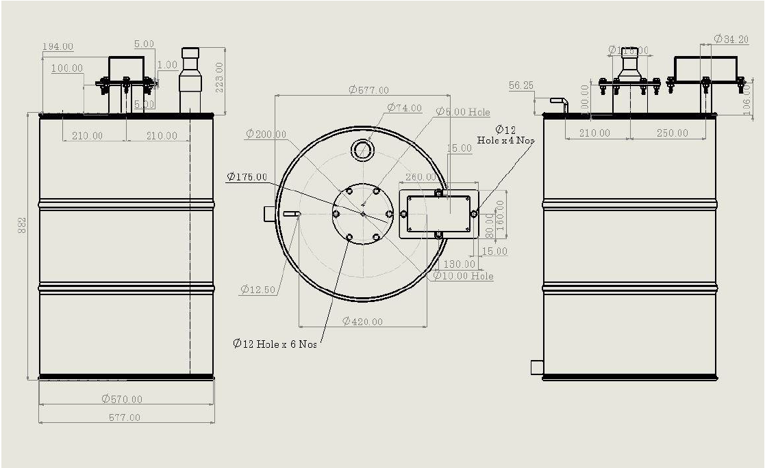

Figure 15 : Dimensions Design